**Parallel stages:**

* We can have parallel stages running in Jenkins with below syntax.

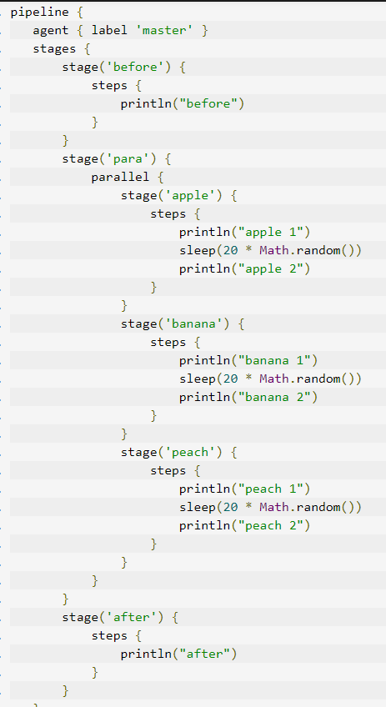

**Permission job:**

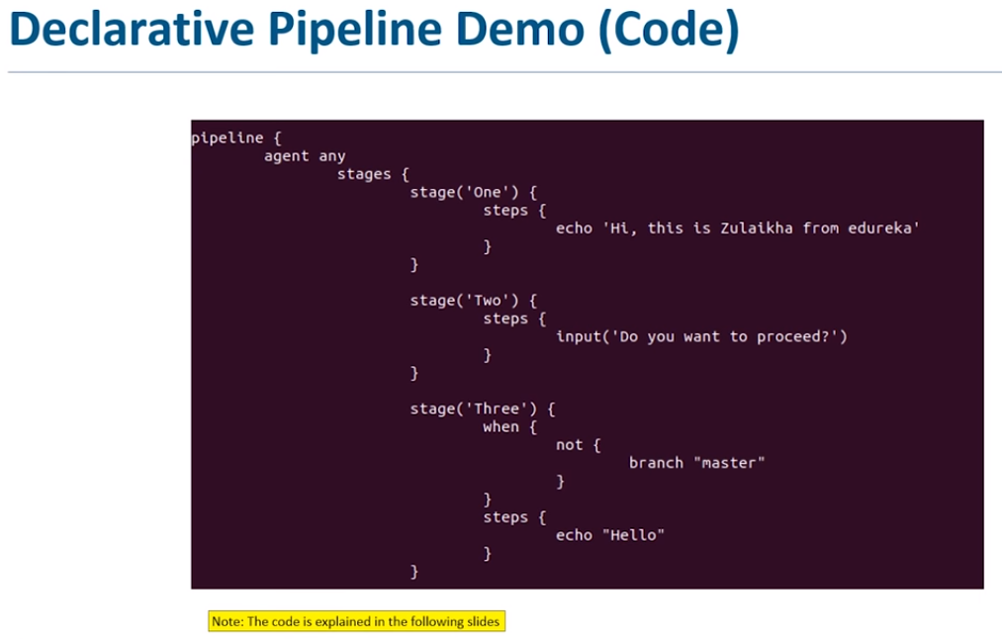

* We can have input with some message as above. So that the Jenkins at that stage will display the message and wait for the approval to process as below.

